2018 Fall CIS400 – Assignment 2
Scripting Languages

Instructor: Dr. Jie Shen
Release date: October 16, 20178
Due date: November 4, 2018

Scripting languages provide you much flexibility in handling lists. You should use Perl language to complete the following questions.

Question 1: Perl (10 points).
Write a program that reads a string from the standard input, and uses a Perl regular expression to test whether the string looks like a valid IP address.

Question 2: Perl (25 points).
Write a program that reads a string from the standard input, and match the following patterns:
a) an odd digit followed by an even digit (eg. 12 or 74)
b) a letter followed by a non-letter followed by a number
c) a word that starts with an upper case letter
d) the word "yes" in any combination of upper and lower cases letters
e) one or more times the word "the"
f) a date in the form of one or two digits, a dot, one or two digits,
a dot, two digits
g) a punctuation mark

Question 3: Perl (10 points)
Write a program that takes as input text file (input.txt) and identifies all the email addresses that are embedded in this file, and prints all the email addresses out to an output file called “output.txt”. In the output file, the email addresses should be separated by comma and sorted alphabetically. The screenshot should display at least first twenty email addresses, together with a line number. The first two email addresses will be displayed as

1: xxx@xxx
2: yyy@yyy

, and so on.

Question 4: Perl (10 points).
Write a program that reads a number, adds up all the digits, and
displays the result. Run your code with the following test number:

176298

It should give 33.

Question 5: Perl (10 points).
Write a program that reads a series of digits and it displays
the digits in ascending order, together with their frequency. E.g.,
for the input:

1 7 6 2 9 8 2 0 2 0

the program will display:

0 2
1 1
2 3
6 1
7 1
8 1
9 1

Python provides much better readability than Perl. You should use Python language to complete the following questions.

Question 6: Python (10 points).
In cryptography, Caesar cipher is one of the simplest encryption techniques. The key idea of this method is to replace each plaintext letter with one fixed number of places down the alphabet. Below is an example with a shift of three:

Plain: ABCDEFGHIJKLMNOPQRSTUVWXYZabcdefghijklmnopqrstuvwxyz
Cipher: DEFGHIJKLMNOPQRSTUVWXYZabcdefghijklmnopqrstuvwxyzABC

To cipher a string, ‘A’ is replaced by ‘D’, ‘B’ is substituted by ‘E’, and so on. To decode a string, ‘A’ is replaced by ‘x’, etc.

Write a program that first ask user to do encoding or decoding. Then it reads an input sentence and a number for shift. The output of the program is an encoded sentence or decoded sentence, depending upon user’s choice.

Test your program with a sentence: “Why write in blue or black when you can make your words invisible”. Demonstrate the encoded sentence and the deciphering of the encoded sentence.

Question 7: Python (10 points).
Write a program that takes a URL as an input. It then fetches the web page of that URL, and strips out all of the HTML tags. We assume that a tag is anything between a pair of angular brackets: < … > . Sort all the tags alphabetically, and print out the result on computer screen. Each tag is printed out only once together with its frequency (# of occurrences).

Test URL is https://www.tandfonline.com/toc/tjms20/current.

Question 8: Python (10 points).
The distribution of letters in a document has a distinctive and predictable shape, as shown in the following figure. This distribution could be effective information to break a cipher. Write a program that reads an input file, and outputs the count or frequency of all 26 letters to an output file: count.dat. Case sensitivity is not considered, i.e., ‘a’ is treated as the same as ‘A’. Test file is “constitution.txt” at Canvas.

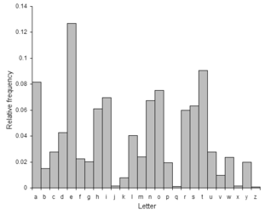

Question 9: Python (15 bonus points).

This is a bonus question. You may choose to not do it if you don’t want these 15 bonus points.

Sudoku is a popular logic game. Each Sudoku puzzle is represented by a 9x9 grid, subdivided into 9 3x3 cells. Several cells are initially filled by values between 1 and 9. The objective is to fill the remaining cells with digits so that no digit is ever repeated in any column, row, or 3x3 blocks. Write a python code that can provide a solution to the following test case:
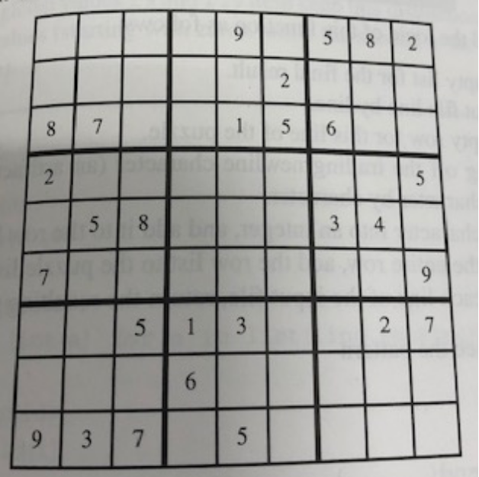

In your answer, write one or two paragraphs to describe the solution strategies used in your code.

Submission of Your Work:

(1) The Word document should contain the following information
- Your name
- Machine type
- Interpreter type
- Description of your code design and implementation
- Inclusion of your source
- Test case design and screen shots

